Lab 2
Worksheet
DC Circuits
As you work through the steps in the lab procedure, record your experimental values and the
Results on this worksheet. Use the exact values you record for your data to make later calculations.
Procedure A: Reading the color code of unknown resistors.
Complete the data table-1 below
Table-1
Resistor | Band 1 |  | Band 2 |  | Band 3 |  | Resistance
Resistor | Color | Value | Color | Value | Color | Value
1 | Blue | 6 | Violet | 7 | Black | 0 | 67 ohm
2 | Green | 5 | Orange | 3 | Brown | 1 | 53 *10¹=530 ohm
3 | Brown | 1 | Black | 0 | Red | 2 | 10*10² =1kOhm
4 | Brown | 1 | Red | 2 | Orange | 3 | 12 * 10³=12kOhm
5 | Blue | 6 | Black | 0 | Red | 7 | 60 * 10²=6kOhm

Table-02
Write down actual and nominal value of resistor(s) and fill the following table.
Resistors | R1 | R2 | R3
R (Nominal) | 67 Ohm | 530 Ohm | 1k Ohm
R (Actual) | 70 Ohm | 519.2 Ohm | 992 ohm

Table 3
Trial | Voltage(V) | Current(I)
1 | 5V | 0.05A
2. | 6V | 0.06A
3. | 7V | 0.07A
4. | 8V | 0.08A
5. | 9V | 0.09A

Attach graph Current VS Voltage (Make graph in MS Excel)
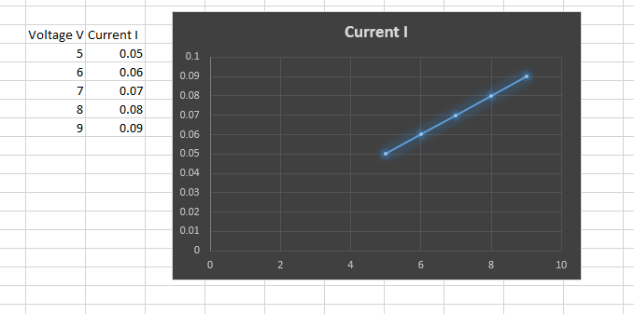

Answer the following questions.

Q#1: Ohm's law will generate which type of graph?
Ans: Ohm's Law generates a straight-line graph.

Qno-02: Why we study Applied Physics?
Ans: Applied Physics bridges theory and real-world applications, empowering us to unravel the universe's secrets and create innovative technologies.

Q03: What are the applications of Ohm's Law in real life?

Ans:
1. Conventional Domestic Fans: We control fan speed by adjusting the resistance using a regulator.

2. Electric Heaters: Ohm's Law helps calculate the power supplied to heaters.

3. Electric Kettles and Irons: The resistors in these appliances determine heat output.

4. Design of Electric Devices: Ohm's Law guides resistance selection for specific currents.

5. Fuse Design: Fuses limit current flow and use Ohm's Law for resistor selection.

6. Mobile and Laptop Chargers: Ohm's Law governs their DC power.

Q#4. Find the resistance of the following resistors using color coding scheme.
SNO | Resistor | Value | Range
 | 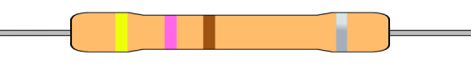 | 47 Ohm | 42.3 ohm to 51.7 ohm
 |  | 7.6k ohm | 7.2k ohm to 7.9k ohm
 | 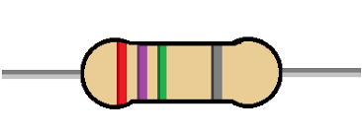 | 2.7 Mega Ohm | 2.6 Mega Ohm to 2.8Mega Ohm
 | 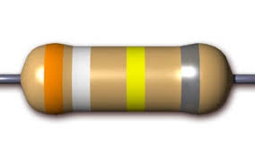 | 390K Ohm | 386KOhm to 393koOhm

